Accident / Injury Report

Instructions: Complete this form as soon as possible after any incident that results in an injury, illness or near miss. Collect as much information as possible and then submit report to the Safety Department and a stamped copy to Human Resources as soon as possible.

This is a report of a:  Death  Lost Time  Medical Treatment  First Aid Only  Near Miss
Date of incident: | This report is made by:  Employee  Supervisor  Team  Other_________

Step 1: Injured employee (complete this part for each injured employee)
Name:  Address :  Phone:  Emergency Contact: | Sex:  Male  Female |  | DOB:
Facility/Department: | Job title at time of incident:
Part of body affected: (shade all that apply)  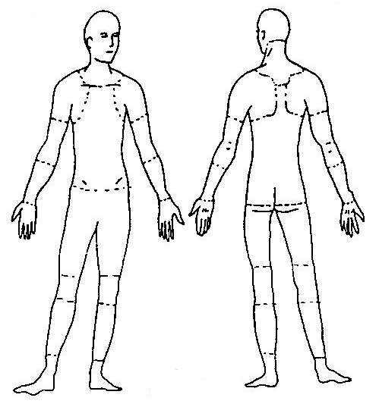 | Nature of injury: (most serious one)   Abrasion, scrapes   Amputation   Broken bone   Bruise   Burn (heat)   Burn (chemical)   Concussion (to the head)   Crushing Injury   Cut, laceration, puncture   Hernia   Illness   Sprain, strain   Damage to a body system:   Other ___________ | This employee works:   Regular full time   Regular part time   Seasonal   Temporary
Months with
this employer:
Months doing
this job:

Step 2: Describe the incident
Exact location of the incident: | Exact time:
What part of employee’s workday?  Entering or leaving work  Doing normal work activities
❑ During meal period  During break  Working overtime  Other___________________
Names (first and last) of witnesses and statements (Contact Information if applicable):

Attachments  (#, Yes or No) | Written witness statements: | Photographs: | Maps / drawings:
What personal protective equipment was being used (if any)?
Employee’s statement: Describe, step-by-step the events that led up to the accident/injury. Include names of any machines, parts, objects, tools, materials and other important details.

Description continued on attached sheets: 

Accepted Recommended Medical Treatment:  Yes  No  N/A

If yes, where was employee taken for treatment and by whom: ____________________________________

Employee Signature/Date:___________________________________

Step 3: Why did the incident happen?
Unsafe workplace conditions: (Check all that apply)   Inadequate guard   Unguarded hazard   Safety device is defective   Tool or equipment defective   Workstation layout is hazardous   Unsafe lighting   Unsafe ventilation   Lack of needed personal protective equipment   Lack of appropriate equipment / tools   Unsafe clothing   No training or insufficient training   Other: _____________________________  Why did the unsafe conditions exist? | Unsafe acts by people: (Check all that apply)   Operating without permission   Operating at unsafe speed   Servicing equipment that has power to it   Making a safety device inoperative   Using defective equipment   Using equipment in an unapproved way   Unsafe lifting   Taking an unsafe position or posture   Distraction, teasing, horseplay   Failure to wear personal protective equipment   Failure to use the available equipment / tools   Other: __________________________________  Why did the unsafe acts occur?
Is there a reward such as “the job can be done more quickly “or “the product is less likely to be damaged”?
❑ Yes  No

May have this encouraged the unsafe condition or act?  Yes  No
If yes, describe:
Were the unsafe acts or conditions reported prior to the incident?  Yes  No
Have there been similar incidents or near misses prior to this one?  Yes  No
Other Comments:

Step 4: How can future incidents be prevented?
What changes do you suggest to prevent this incident/near miss from happening again?

❑ Stop this activity  Guard the hazard  Train the employee(s)  Train the supervisor(s)

❑ Redesign task steps  Redesign work station  Write a new policy/rule  Enforce existing policy

❑ Routinely inspect for the hazard  Personal Protective Equipment  Other: ____________________

What corrective action should be (or has been) done to carry out the suggestion(s) checked above?

Description continued on attached sheets: 

Has corrective action been implemented and if so, date of implementation?  Yes  No Date:______________

Step 5: Who completed and reviewed this form? (Please Print)
Written by:  Department: | Title:  Date:
Names of investigation team members (If applicable):

Has Temporary Agency been notified of accident/injury:  Yes  No Initials/Date:_________________
Reviewed by:

Name: _______________________ Title: _________________________ Date: __________

Name: _______________________ Title: _________________________ Date :__________

Name: _______________________ Title: _________________________ Date :__________

